Scenario 1: Process Monthly Interest

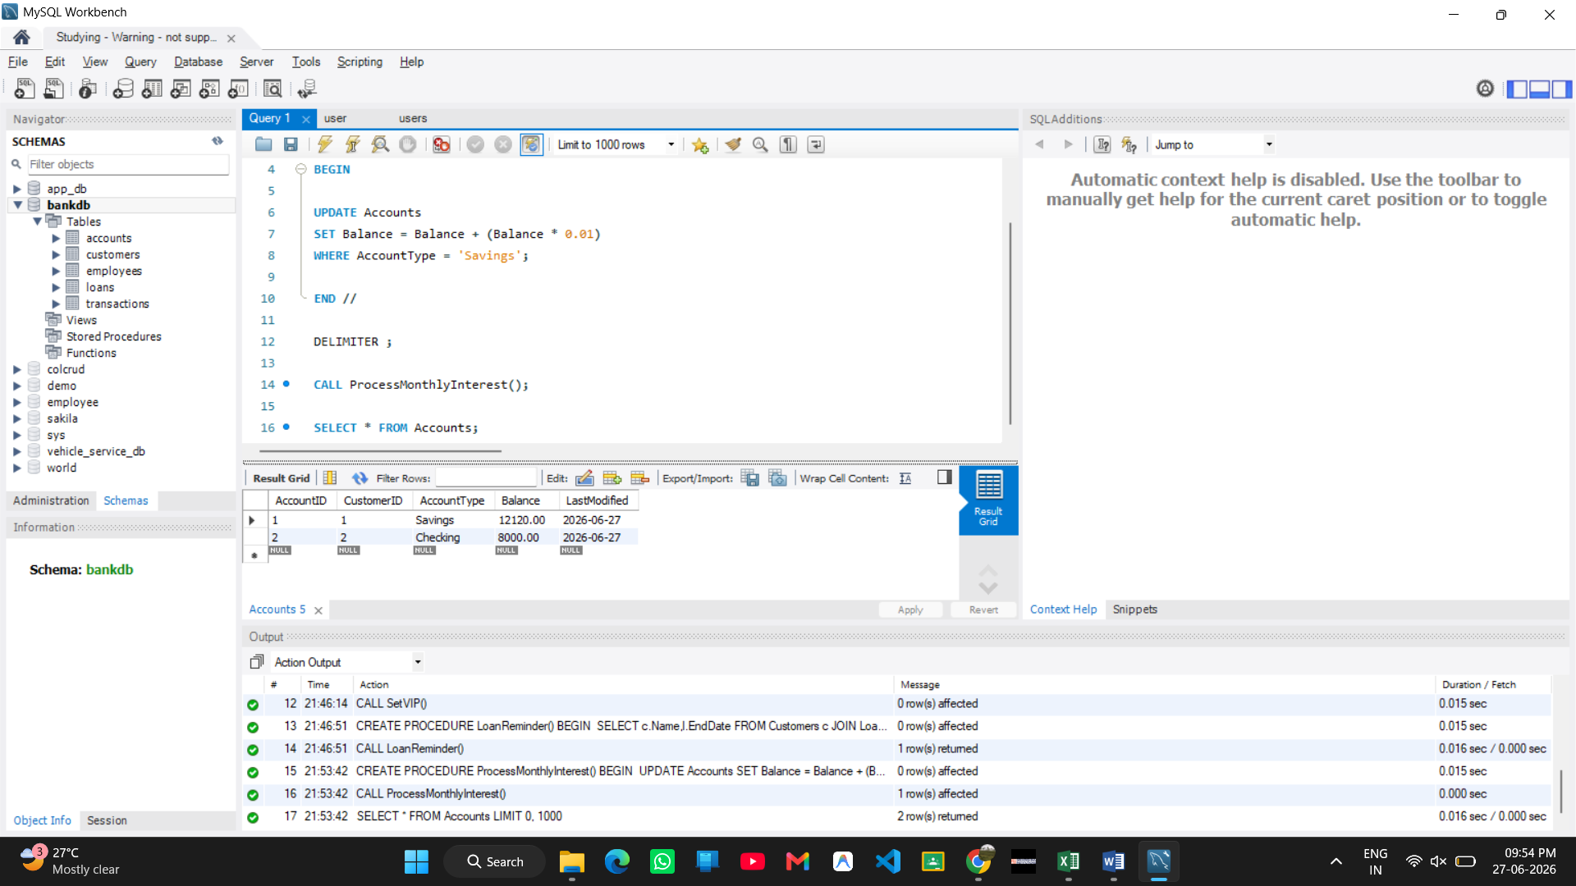

Scenario 2: Update Employee Bonus

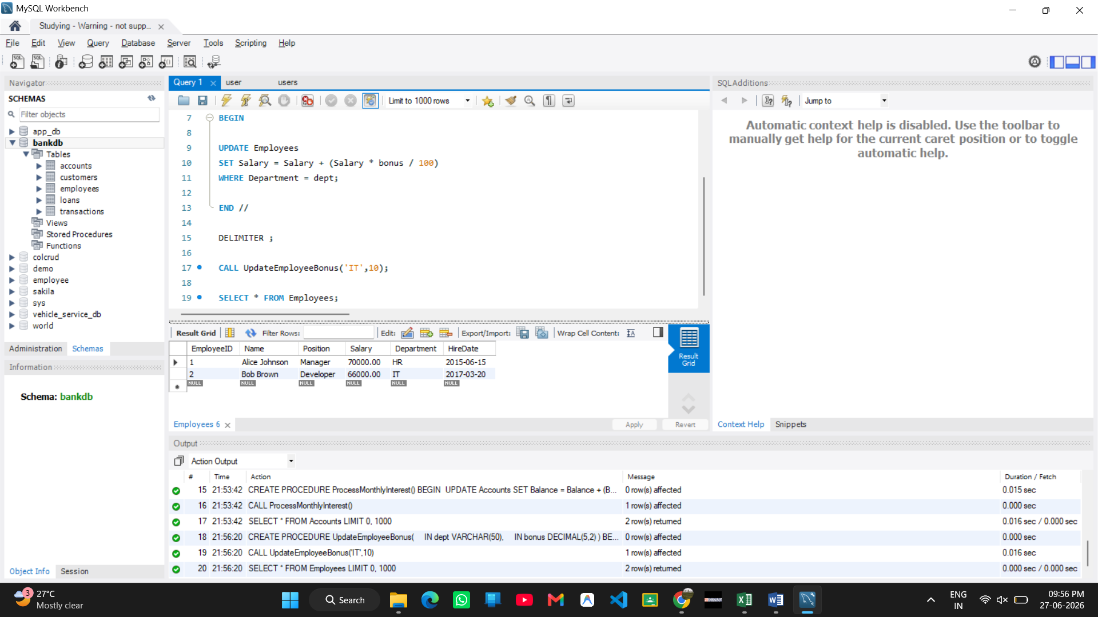
Scenario 3: Transfer Funds

